UE24CS341A - Software Engineering
Lab 3: Component Modelling & Architectural Pattern Selection
Name: Rohanth Ganesha C
SRN: PES1UG24AM227

1. Component Diagram
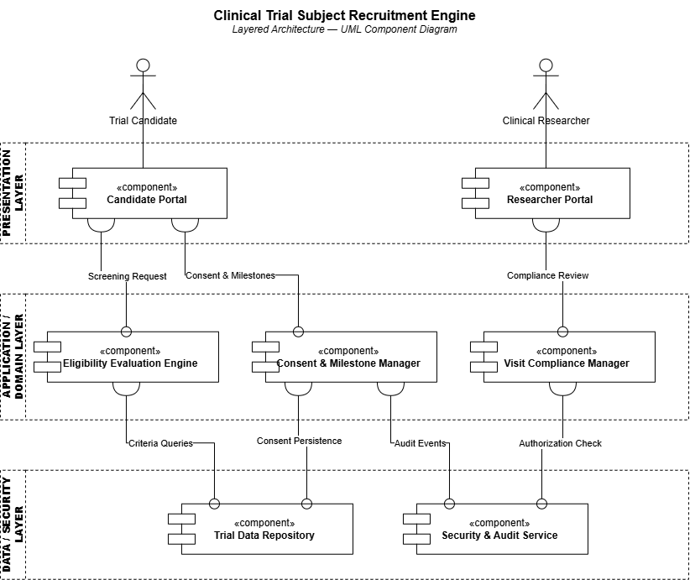

2. Architecture Selection

Architectural Choice
The Clinical Trial Subject Recruitment Engine requires clear separation between candidate and researcher interactions, recruitment business logic, and storage of clinical-trial records. A Layered Architecture organizes the system into Presentation, Application/Domain, and Data/Security layers, making these responsibilities easier to manage and maintain.

Two Reasons for the Choice
1. Clear separation of responsibilities: The Presentation Layer can handle Trial Candidate and Clinical Researcher interactions, while the Application/Domain Layer manages eligibility evaluation, informed-consent milestones, and visit-compliance tracking. This separation makes the individual functions easier to maintain and test.
2. Centralized management of clinical-trial data: The Data/Security Layer can centrally manage subject records, trial criteria, consent information, and visit-compliance records. This is suitable for a system that requires consistent access to clinical-trial information and controlled handling of sensitive records.

Security Advantage
Layered Architecture allows security controls to be centralized before access reaches sensitive trial data. A dedicated Security & Audit Service can enforce authorization and maintain audit records of important system activities, supporting the scenario's requirement for auditable clinical-trial records and cryptographic audit trails.

Performance Benefit
Layered Architecture can provide predictable performance because closely related recruitment operations are handled within the Application/Domain Layer without the additional network communication required between many independently deployed services. This can support efficient eligibility evaluation and retrieval of trial records.

Conclusion
Layered Architecture provides a suitable balance of separation of responsibilities, centralized data management, security, and performance for the Clinical Trial Subject Recruitment Engine.

